**Benefice Diary  
 November 2024**



**FROM REVD KAREN**We are entering the Remembrance and Christmas Season. Most of what happens this year happened last year, which is a huge relief when it comes to planning! We are introducing an Advent Carol service this year at St Edward’s on the 1st December. I would love to bring back a crib service at St Edward’s but I’m still getting over Covid and need to be mindful of my energy levels and the capacity of our volunteers over the Christmas Season

**BENEFICE CONTACTS**Reverend Karen Wellman 01451 831567

revdkaren@stedwardsstow.org.uk

**CHURCHWARDENS:**

Stow-on-the-Wold Vacant

Condicote Chris Wynn 830389 and Adam Fleming

The Swells Jolyon Grey 822215 and Hazel James 831367

**THE ‘STOW CRUCIFIXION’**

If you have been into St Edward’s, Stow, in the past week you will have noticed something missing from the wall near the South Door. The long overdue professional conservation of our very large 17th - century painting of the Crucifixion got underway on 23rd October. In a fascinating process, the painting was carefully removed from the wall, given initial cleaning

and protective repairs, removed from its frame and then rolled around a large drum before being removed to the Bristol studio of International Fine Art Conservation Studios. The painting will be returned to Stow after about five months. In view of the size of the canvas, the conservation process is very expensive and far beyond any justifiable cost for St Edward’s. However, the painting has been an integral part of the church’s heritage since 1837, and needs to be kept in a fit condition for the benefit of future generations. Fortunately, we have been successful in getting grants and donations that

cover most of the cost from The National Lottery Heritage Fund, the Ian M Foulerton Charitable Trust, the National Churches Trust, the Leche Trust, St Andrew’s Conservation Trust, Laslett’s (Hinton) Charity and private donors.

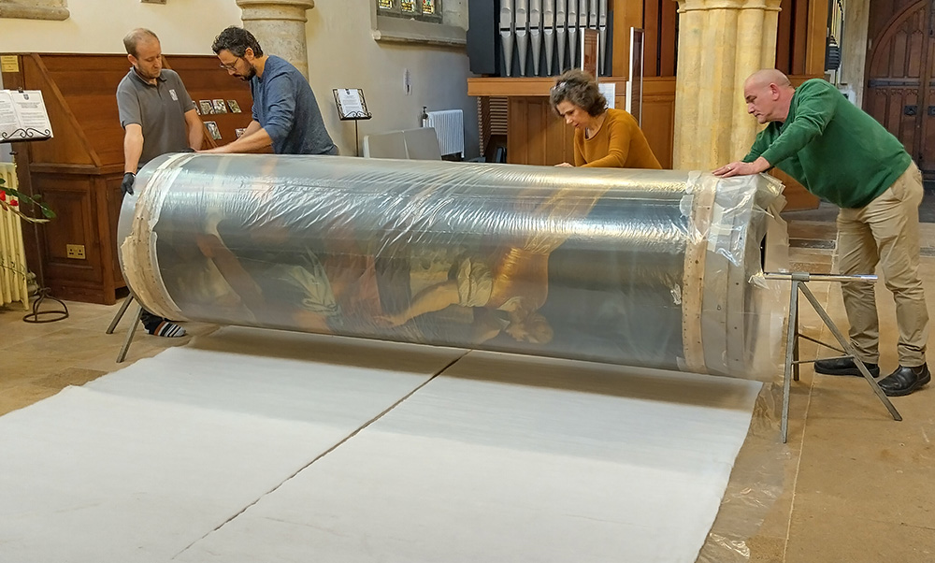

**CRIB FESTIVAL**Please can you let us know if you planning to bring or share a nativity scene. The festival runs from Friday afternoon on the 6th December to Sunday evening of the 8th December.

**MU COFFEE MORNING**There is a coffee morning on Thursday 7th November 10-12noon with cakes, biscuits, books, bric a brac, bring n buy, and Jeanie’s gems jewellery, all in aid of branch funds.

**PHILIP’S FUNERAL**Philip Morgan’s funeral will be on Wednesday 20th November at noon at St Edward’s Church.

**REMEMBRANCE SUNDAY 10th November 2024 10.50am**

This is the first year that Stow Town Council will be organising the event. It is expected that the parade and service will be the same as last year. There will be a short Act of Remembrance at the cross in the town square at 10.30 on the 11th November led by the children of Stow Primary School.

**CHRISTMAS SERVICES**This is what we have so far:

Sunday 1st December Advent Carol Service St Edward’s   
Friday 13th December 2pm Mother’s Union Advent Carol Service at St Edward’s  
Friday 13th December 6.30pm Kate’s Carol Service

Thursday 19th December 5.30pm Nativity Service at St Mary’s Lower Swell

Friday 20th December 6pm St Mary’s Upper Swell Carol Service

Sunday 22nd December 3pm St Edward’s Carol Service   
Tuesday 24th December 5pm St Nicholas’ Crib Service

Tuesday 24rd December 11.30pm St Edward’s Midnight Mass

Wednesday 25th December 9am St Nicholas’

Wednesday 25th December 10.30pm Christmas Service St Edward’s   
Sunday 29th December 10.30am Holy Communion at St Edward’s

**REGULAR EVENTS  
CLOSELY KNIT** 10am —noon every Saturday in St Edward’s Church.

**MOTHER’s UNION**- first Thursday of the month 2.00pm in the Church Room.

**COSWOLD DEMENTIA CAFÉ** Every 1st and 3rd Friday of the month, 2-4pm at the Baptist Church Hall off Back Walls. A community café offering friendship, support, advice and more for anyone living with or caring for someone with dementia.

**NOVEMBER SERVICES**

MONDAYS 9.00am Morning Prayer St Edward’s Stow

SUNDAY 3rd November   
10.30 am Holy Communion St Edward’s Stow

THURSDAY 7th November  
11.00 am Holy Communion Newlands Court

SUNDAY 10th November Remembrance Sunday   
9.15 am BCP Holy Communion St Nicholas’ Condicote  
10.50 am Remembrance Sunday Service St Edward’s Stow   
11.00 am Matins (lay-led) St Mary’s Upper Swell

SUNDAY 17th November   
9.15 am BCP Holy Communion St Mary’s Upper Swell  
10.30 am Holy Communion St Edward’s Stow  
2.30 pm Dementia Friendly Service Edwardstow Court

6.00 pm All Souls Service St Mary’s Lower Swell TBC

WEDNESDAY 20th November

12noon Funeral Service St Edward’s Stow  
  
SUNDAY 24th November   
9.15 am BCP Matins St Nicholas Condicote   
10.30 am Holy Communion St Edward’s Stow

*All Sunday services from St Edward’s Church Stow-on-the-Wold are streamed unless the technology decides not to behave! There is no streaming on the 24th November.*